## 2017 Green & Gold

**FOOTBALL CAMP**

**Four Individual Camp Sessions**   
June 30, July 7, July 14, July 21  
8:00 – 10:30 AM

**Location:**   
Football Field  
Count Basie Complex

11 Henry St  
Red Bank, NJ

***\*\*Each player receives a***

***Green & Gold Camp T-Shirt***

Red Bank Catholic High School  
112 Broad St.  
Red Bank, NJ 07701  
  
for more information:  
Athletic Office: 732-747-1211  
Email: [camps@rbcsports.com](mailto:camps@rbcsports.com)

**REGISTER ONLINE**  
Go to “Athletics” on the RBC website awww.redbankcatholic.org

Green & Gold

FOOTBALL

2017

*Passing Academy*

**Red Bank Catholic High School**

**Athletic Department**

**112 Broad St.**

**Red Bank, NJ 07701**





**R**ed **B**ank **C**atholic

High School

**Red Bank Catholic High School**

112 Broad St.

Red Bank, NJ 07701

**Camp Location:**

Count Basie Complex, Red Bank, NJ

**For BOYS Entering 5th-8th Grade**

**CAMP SESSIONS:**

**June 30, July 7, July 14,**

and **July 21, 2017**

Caption describing picture or graphic.

## Enrollment is Limited!

## 

# CAMP GOALS

**Passing Academy**

2017 GREEN and GOLD FOOTBALl: Passing Academy *Registration*  
Name___________________________________________________________ Present Grade (’16-17 school year)__________Age________

Parent’s Name________________________________________________Home Phone___________________Cell Phone___________________  
Address________________________________________________City________________________________State________Zip_____________  
Parent emai address___________________________________________ Sessions (circle) 6/30 7/7 7/14 7/21  
 ABSOLUTELY NO REFUNDS $25 Deposit enclosed, balance to be paid 1st day of clinic or pay in full now.  
Please make checks payable to: Red Bank Catholic Athletic Dept. and mail, along with Registration form to  
Athletic Dept., Red Bank Catholic High School, 112 Broad St., Red Bank, NJ 07701.  
I understand that any camper who does not abide by the rules and regulations promulgated by the camp is subject to dismissal without reimbursement or recourse. I also understand that the Green and Gold Football Clinic is not responsible for any campers leaving the grounds of Red Bank Catholic. The camp will not be responsible for injury or illness if same is not caused through fault of the camp. I hereby authorize the directors of the Green and Gold Camp to act for me according to their best judgment in any emergency if I cannot be contacted. I understand that each camper is required to provide his own medical and accidental insurance.   
 Parent Signature: ________________________________________________________Date_____________

***REGISTER EARLY***

**To register online**

go to “Athletics” on the RBC website:

www.redbankcatholic.org

**2017 Camp Dates:**June 30, July 7, July 14, July 21  
8:00 – 10:30 AM

$50 per session

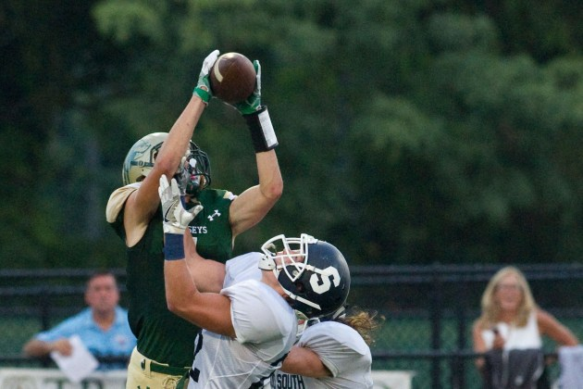

Camp Director:  
 Frank Edgerly

Former NFL scout and coach with the New England Patriots and Cleveland Browns and current head coach at Red Bank Catholic.

Coach Edgerly and his staff have developed a highly-productive offensive system that equips their players with the skills and knowledge to be successful at the collegiate level.

* Intense individual, group, and unit instruction on all aspects of the passing game.
* Heavy emphasis on individual skill development and execution of the basic, intermediate, and advanced concepts used at the high school and collegiate levels.

|  |  |  |
| --- | --- | --- |
| **QUARTERBACKS** |  | **WIDE RECEIVER** |
| 1. Footwork / agility  2. Passing technique and fundamentals  3. 3/5 step drop mechanics, reads, and route concepts  4. Screen and play action mechanics and concepts  5. Sprint and movement technique  6. Coverage identification  7. Conceptual read progressions | 1. Footwork / agility  2. Stance and starts  3. Pass catching fundamentals  4. Route running technique from outside and inside alignments  5. Age/level applicable route concepts  6. Perimeter screens  7. Coverage identification and sight adjustments  8. Ball security |
| **RUNNING BACK** | **TIGHT ENDS** |
| 1. Footwork / agility  2. Pass catching fundamentals  3. Route running from both the backfield and split out alignments  4. Screens from the backfield and split out alignments  5. Pass protection fundamentals  6. Blitz protection and route adjustments  7. Ball security | 1. Footwork / agility  2. Stance and start from tight and split alignments  3. Pass catching fundamentals  4. Route running from tight and split alignments  5. Age/level applicable route concepts  6. Coverage identification and sight adjustments  7. Ball security |

**WHAT TO BRING:**

* T-shirt, shorts, and cleats
* a football size-specific to your level of play

marked with your initials.