2017 Green & Gold
BASEBALL CAMP

Green & Gold

BASEBALL

Camp

2017
Daily 9:00 AM to 1:00 PM
July 10- July 13
July 17 -July 20
Camp Location:
Count Basie Complex
11 Henry St
Red Bank, NJ

Red Bank Catholic High School
112 Broad St.
Red Bank, NJ 07701
for more information:
Athletic Office: 732-747-1211
Email: camps@rbcsports.com
REGISTER ONLINE
Go to “Athletics” on the RBC website at: www.redbankcatholic.org

Red Bank Catholic High School
Athletic Department
112 Broad St.
Red Bank, NJ 07701

For BOYS Ages 7-15

Week 1: July 10th – July 13th
Week 2: July 17th – July 20th

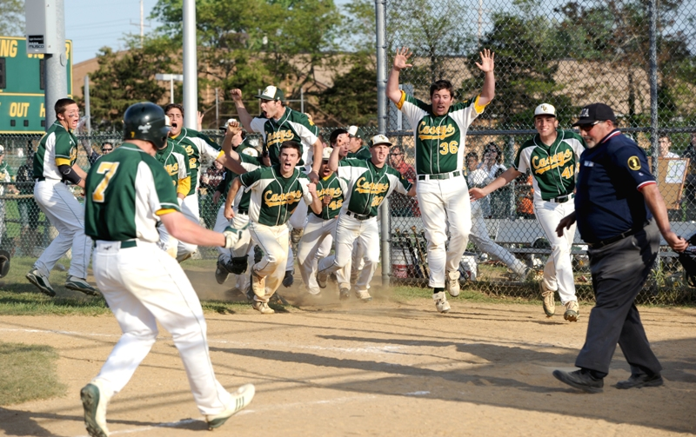
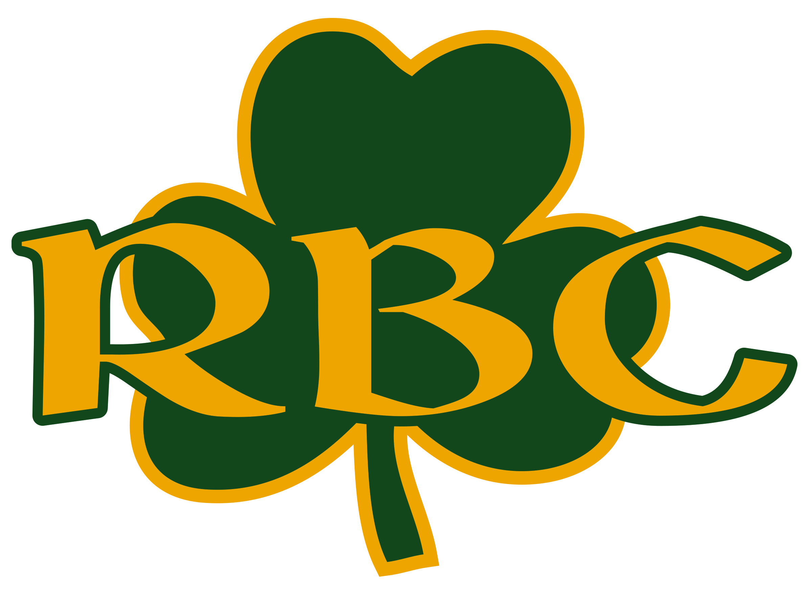
Red Bank Catholic High School
112 Broad St.
Red Bank, NJ 07701

Camp Location:
Count Basie Complex, Red Bank, NJ

Red Bank Catholic
High School

Caption describing picture or graphic.

2017 Baseball Camp Registration
Name___________________________________________________________ Present Grade (’16-17 school year)__________Age________

Parent’s Name________________________________________________Home Phone___________________Cell Phone___________________
Address________________________________________________City________________________________State________Zip_____________
Parent emai address___________________________________________
ABSOLUTELY NO REFUNDS $25 Deposit enclosed, balance to be paid 1st day of camp or pay in full now.
Select Camp Session: Week 1 (July 10-July 13) ____ Week 2 (July 17-July 20)_______
Please make checks payable to: Red Bank Catholic Athletic Dept. and mail, along with Registration form to
Athletic Dept., Red Bank Catholic High School, 112 Broad St., Red Bank, NJ 07701.
I understand that any camper who does not abide by the rules and regulations promulgated by the camp is subject to dismissal without reimbursement or recourse. I also understand that the Green and Gold Baseball Camp is not responsible for any campers leaving the grounds of Red Bank Catholic. The camp will not be responsible for injury or illness if same is not caused through fault of the camp. I hereby authorize the directors of the Green and Gold Camp to act for me according to their best judgment in any emergency if I cannot be contacted. I understand that each camper is required to provide his own medical and accidental insurance.
Parent Signature: ________________________________________________________Date_____________

Enrollment is Limited!

- To develop the fundamental skills needed to play baseball
- To develop offensive skills: hitting, bunting, and base running.
- To develop defensive skills: infield play, outfield play, and catching.
- To develop the mental side of the game: game situations, defensive positioning, and hitting counts.
- To develop ability through drills, game situations, and scrimmages.

CAMP GOALS
REGISTER EARLY
To register online go to “Athletics” on the RBC website:www.redbankcatholic.org
Week 1: July 10th – July 13th
Week 2: July 17th – July 20th
Rain Date: Fridays
$180 per camper

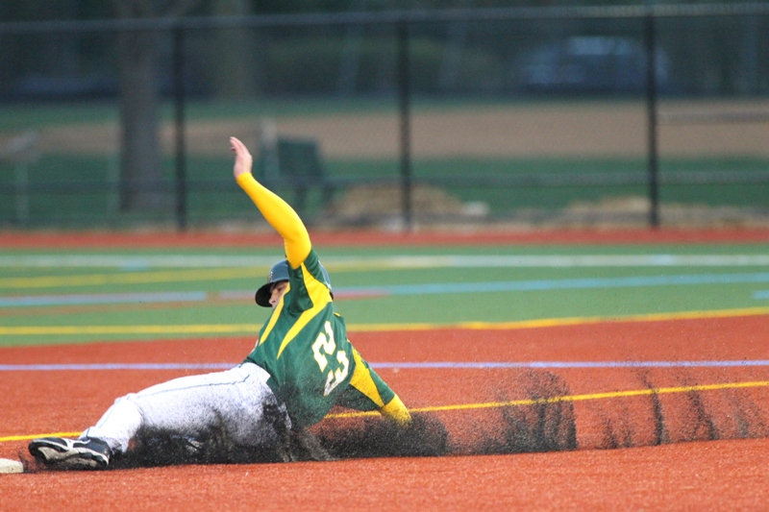
CAMP DIRECTOR:
BUDDY HAUSMANN
-RBC Head Baseball Coach
-1997 RBC State Championship Team
-Pitched at Seton Hall University
-2001 Big East Championship Team
-Drafted by NY Mets 1998 & 2001
-2011 Shore Coach of the Year

PLAYER/COACH RATIO: 9-1

Each player receives a
Green & Gold Camp T-Shirt

LOCATION:
Count Basie Complex, Red Bank, NJ

WHAT TO BRING:
- Bat, glove, cleats, sneakers,
hat, baseball pants.
- A strong desire to learn
and improve.

