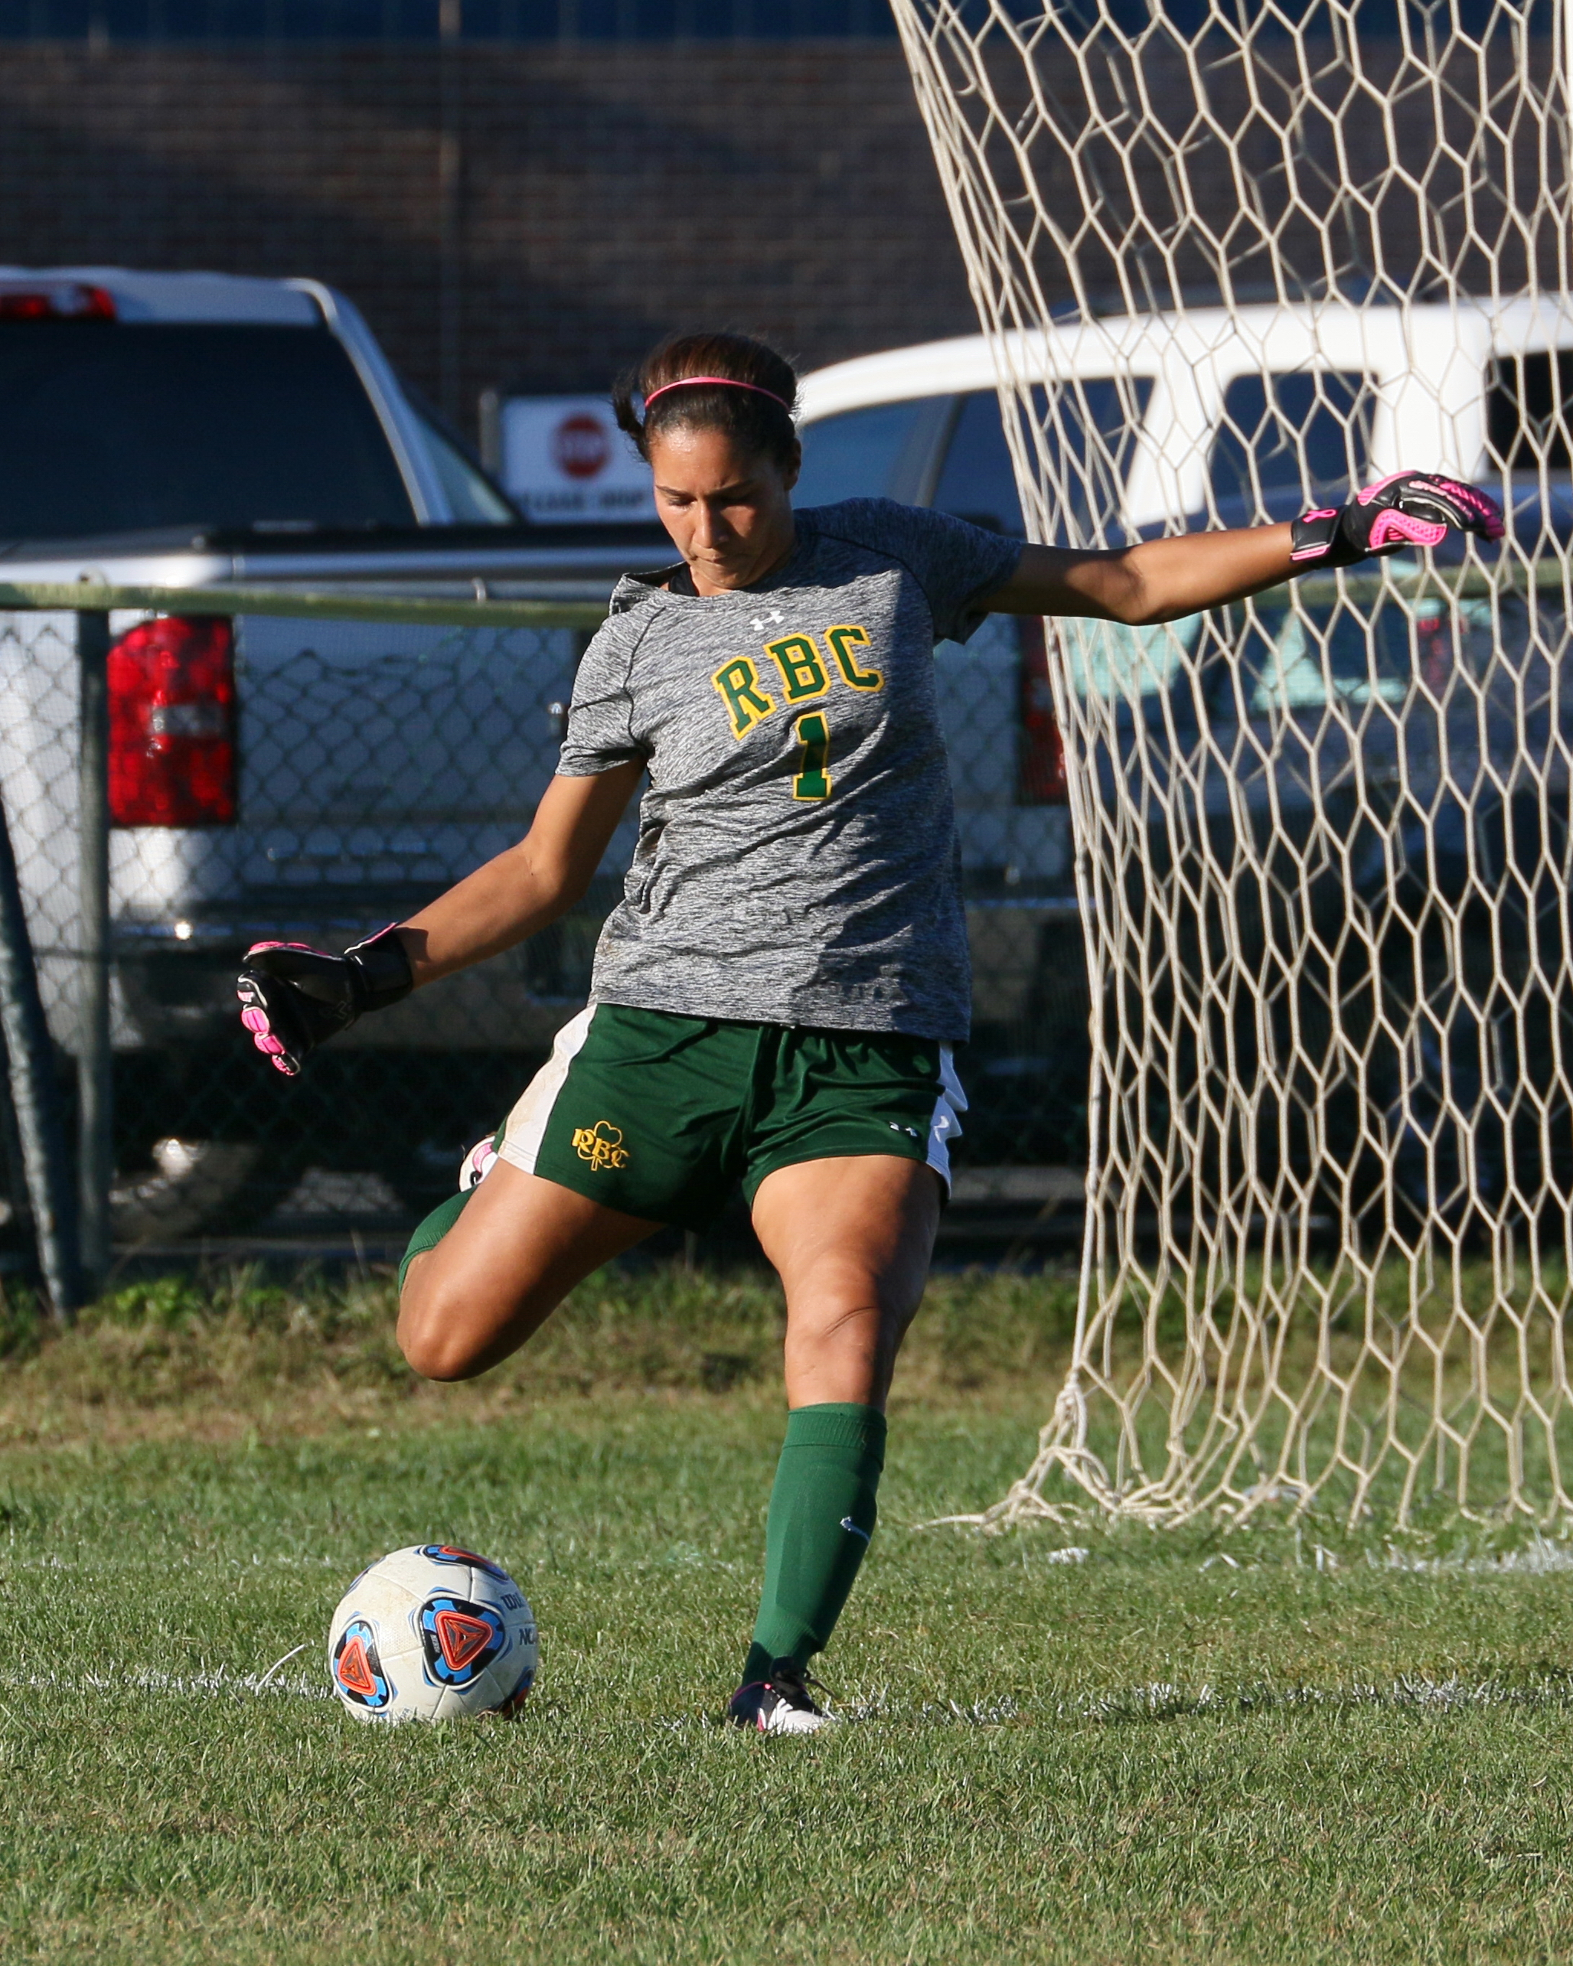
Red Bank Catholic High School
Athletic Department
112 Broad St.
Red Bank, NJ 07701

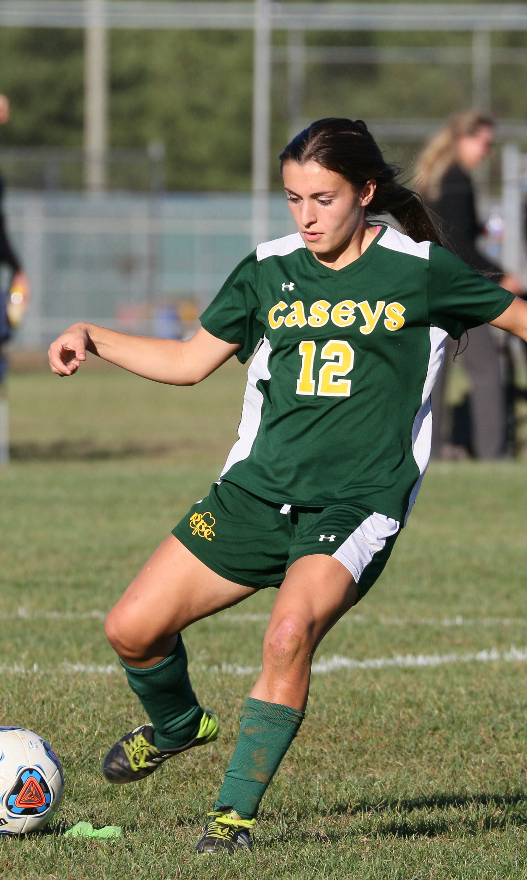

2017 Green & Gold
GIRLS SOCCER CAMP

Green & Gold

GIRLS SOCCER

Camp

2017

Ages 8 – 15

Red Bank Catholic High School
112 Broad St.
Red Bank, NJ 07701
for more information:
Athletic Office: 732-747-1211
Email: camps@rbcsports.com
REGISTER ONLINE
Go to “Athletics” on the RBC website at: www.redbankcatholic.org

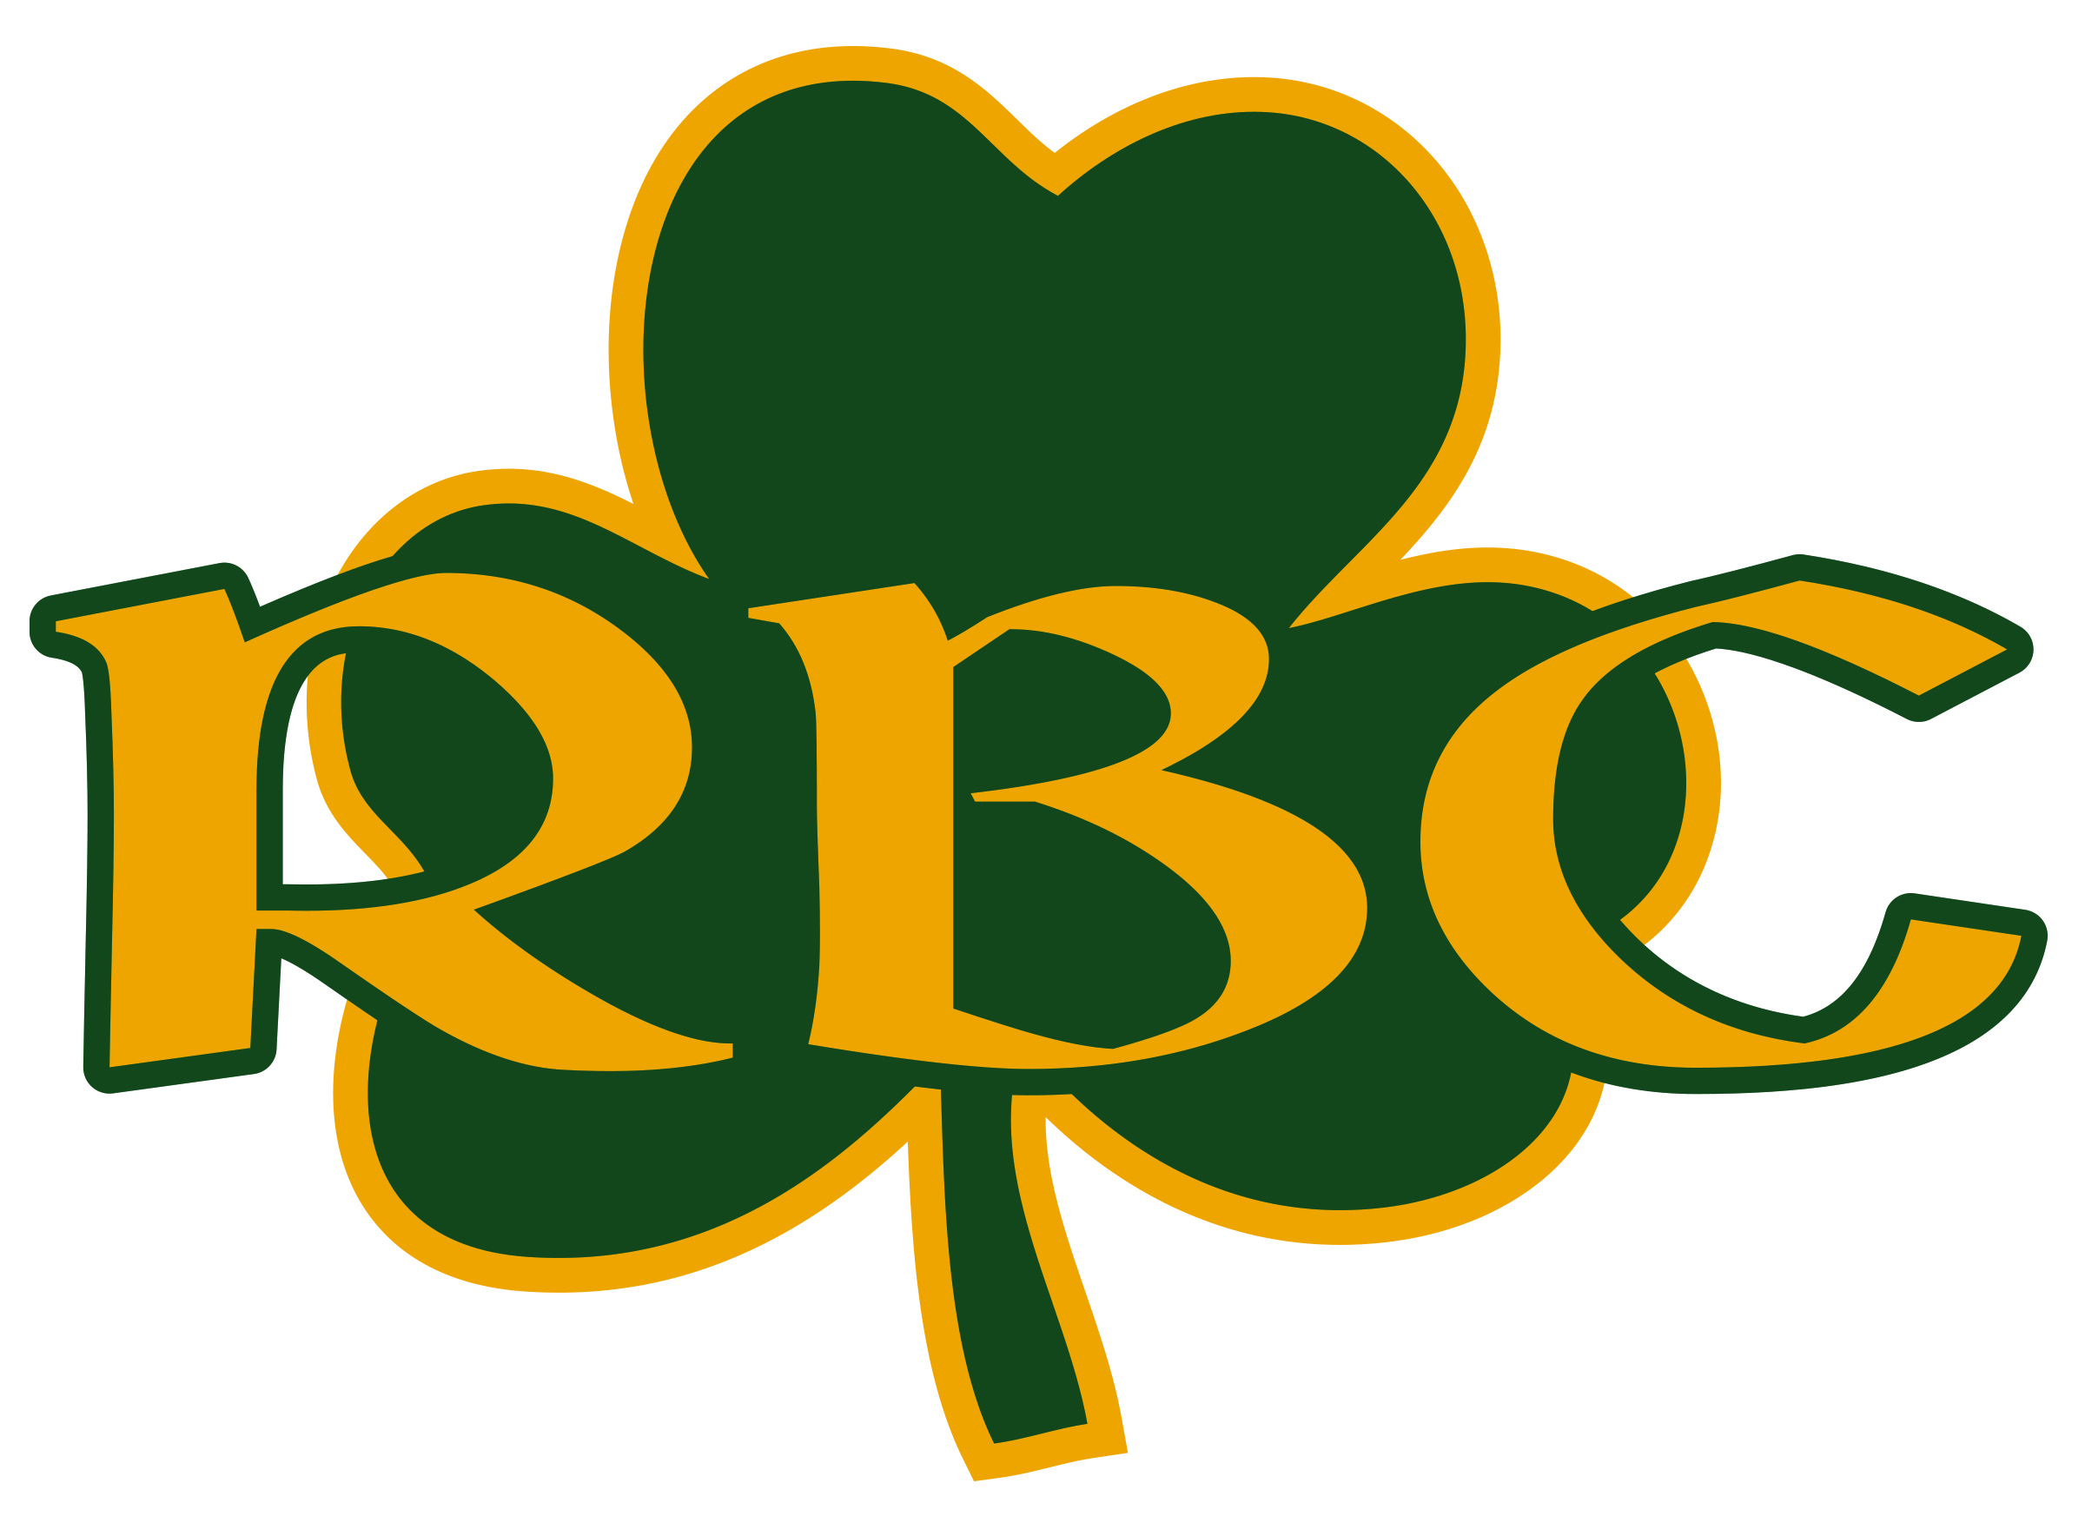
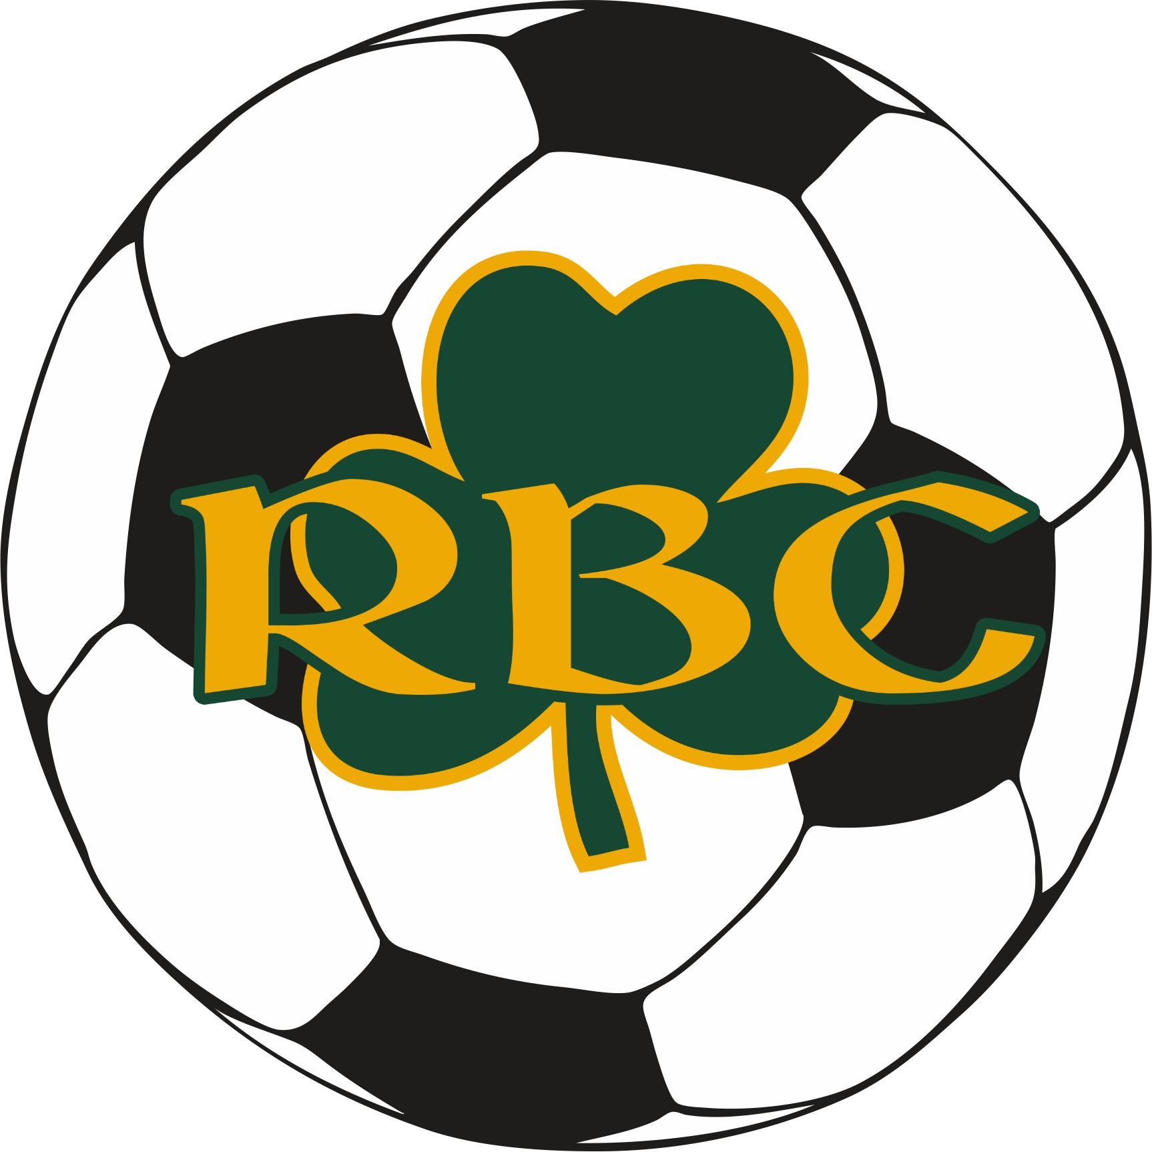

JULY 11th & 12th
6:00-8:00pm
Count Basie Complex
11 Henry St.
Red Bank NJ 07701

Red Bank, NJ 07701

Caption describing picture or

GREEN & GOLD
2017 GIRLS SOCCER CAMP
.
REGISTER EARLY
To register online go to “Athletics” on the RBC website: www.redbankcatholic.org
$100 per camper*

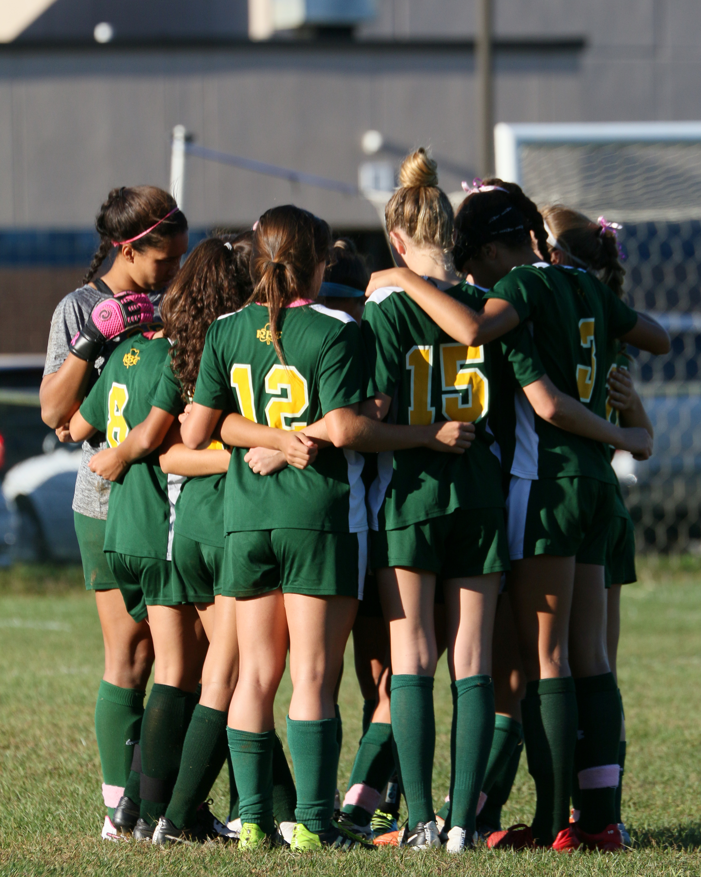

Head RBC Girls Soccer Coach: Frank Lawrence
Coach Lawrence played Soccer at Marquette University where he earned a BA in Economics. He started the Women’s Soccer Program at Brookdale Community College in 1997, leading it to a regional championship and elite eight in the National Tournament the following year. In 14 years the team won 8 conferences, 3 regional championships and was National runner-up in 2006.
Coach Lawrence was a coach and evaluator for the NJ State ODP program, President of the NJCAA coaches association, and national chair for two NSCAA committees.
RBC Caseys won the Shore Conference under the direction of Coach Lawrence in 2013 & NJSIAA Non-Public A Title in 2016.

.
-

Enrollment is Limited!

2017 Girls Soccer Camp Registration
Name___________________________________________________________ Present Grade (’16-17 school year)__________Age________

Parent’s Name________________________________________________Home Phone___________________Cell Phone___________________
Address________________________________________________City________________________________State________Zip_____________
Parent emai address___________________________________________
ABSOLUTELY NO REFUNDS $25 (per session) Deposit enclosed, balance to be paid 1st day of clinic or pay in full now.
JULY 11 & JULY 12, 2017 6:00-8:00pm
Please make checks payable to: Red Bank Catholic Athletic Dept. and mail, along with Registration form to
Athletic Dept., Red Bank Catholic High School, 112 Broad St., Red Bank, NJ 07701.
I understand that any camper who does not abide by the rules and regulations promulgated by the camp is subject to dismissal without reimbursement or recourse. I also understand that the Green and Gold Soccer Camp is not responsible for any campers leaving the grounds of Red Bank Catholic. The camp will not be responsible for injury or illness if same is not caused through fault of the camp. I hereby authorize the directors of the Green and Gold Camp to act for me according to their best judgment in any emergency if I cannot be contacted. I understand that each camper is required to provide his own medical and accidental insurance.
Parent Signature: ________________________________________________________Date_____________

This camp will focus on those core technical skills that are essential to success in a competitive environment. The Coaches will use the 1st hour to teach these skills through drills that are age and skill appropriate. Current RBC players will assist the Coaching staff to ensure each camper receives individualized instruction. While the camp will be competitive, we believe that the players should experience the joy that comes from playing at a high level.

JULY 11 & JULY 12 6-8pm
FOR GIRLS AGES 8-15
Former RBC Players

Danielle Colaprico- United States
Womens National Team & Chicago Red Stars

Brianne Reed – Drafted by FC Kansas City

Liz Thoresen – TCNJ
Grace Correll – Lehigh University
Christina Balacco – Monmouth University
Olivia Lucia – Elon University
Jackie Robinson- Seton Hall University
Sabrina Graziano- Franklin & Marshall

*Group/Team and Multiple Sibling Discounts
are available. Contact RBC (732) 747-1211
camps@rbcsports.com

