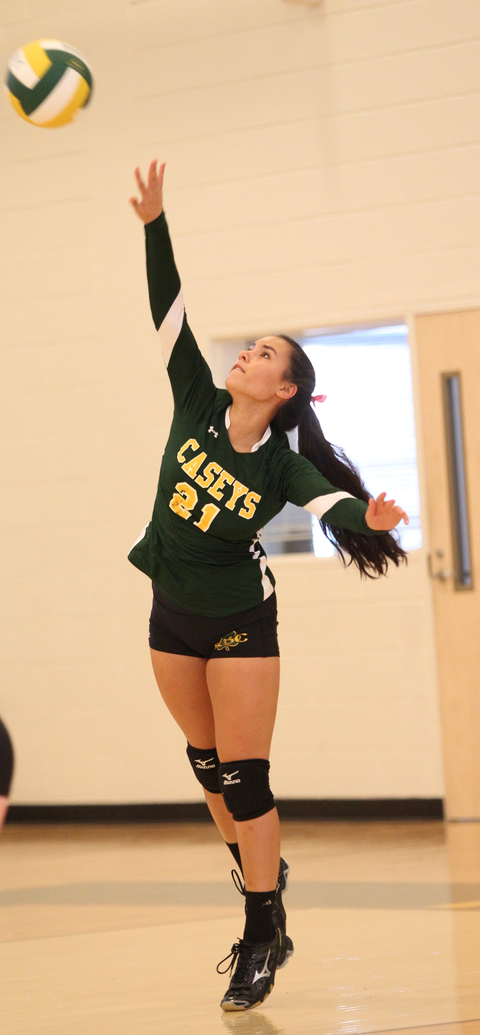
Red Bank Catholic High School
Athletic Department
112 Broad St.
Red Bank, NJ 07701

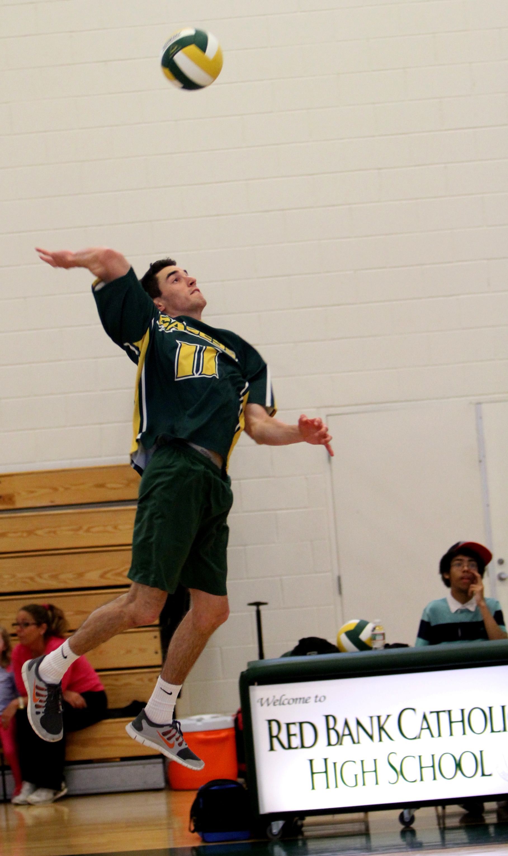

2016 Green & Gold
VOLLEYBALL CLINICS

Green & Gold

VOLLEYBALL

Clinics

2016

For BOYS and GIRLS
Grades 5 - 8
ONE DAY CLINICS
5:00 – 8:00 PM

CLINIC 1: JULY 14
CLINIC 2: JULY 21

Red Bank Catholic High School
112 Broad St.
Red Bank, NJ 07701
for more information:
Athletic Office: 732-747-1211
Email: camps@rbcsports.com
REGISTER ONLINE
Go to “Athletics” on the RBC website at: www.redbankcatholic.org

SPONSORED BY:
THE JEEP STORE
SEAVIEW CHRYSLER/JEEP/DODGE
810 ROUTE 35
OCEAN, NJ

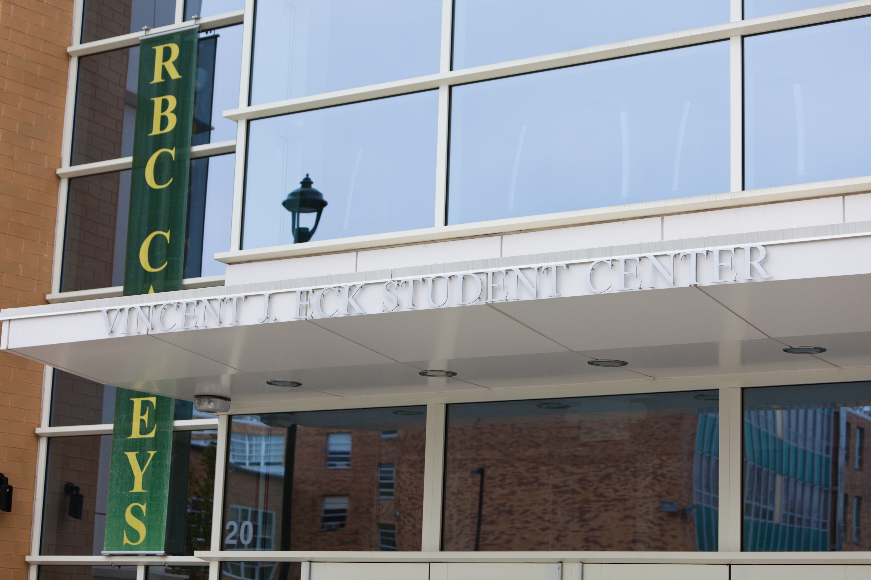

Red Bank Catholic High School
112 Broad St.
Red Bank, NJ 07701

Caption describing picture or
REGISTER EARLY
To REGISTER ONLINE go to “Athletics” on the RBC website: www.redbankcatholic.org

$50 per player

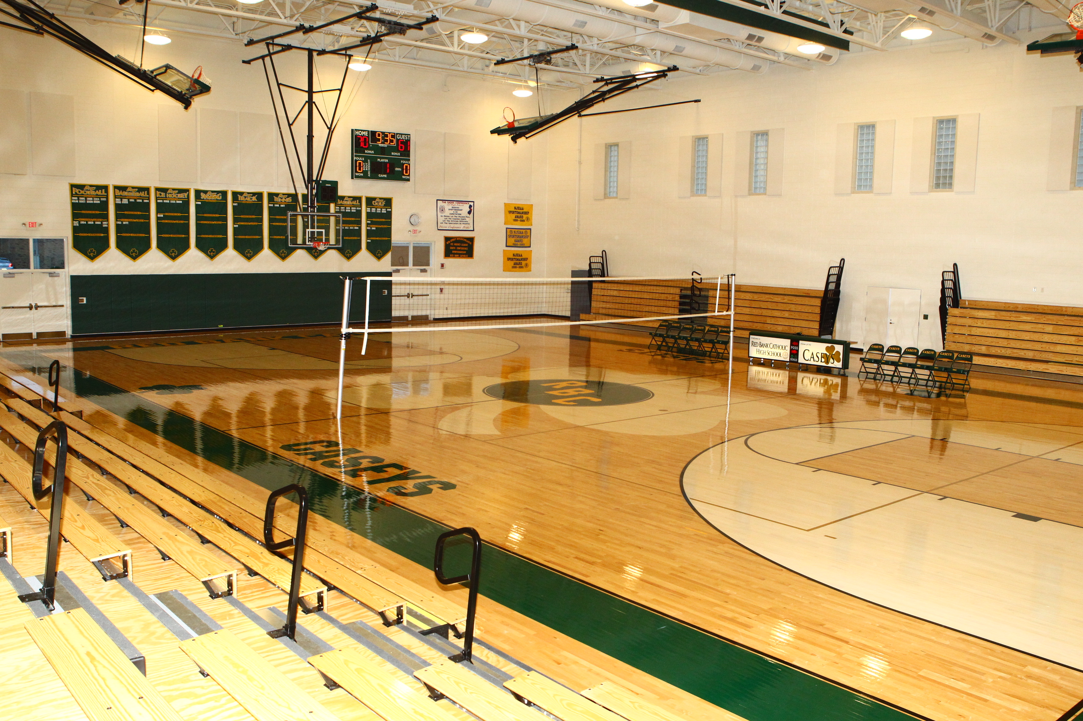

CLINIC DIRECTOR: Pete Bogdan
Head Coach, RBC Girls and Boys Volleyball programs since their inception in 2010. His teams at RBC have won 8 Division Titles in 11 seasons to date. Coach Bogdan has been a varsity head coach in the Shore Conference for over 20 seasons, and has over 250 varsity victories to his credit. In 2010 Coach Bogdan was selected as the Asbury Park Press Girls Volleyball Coach of the Year. He is a member of the American Volleyball Coaches Association (AVCA), and is CAP, IMPACT and SafeSport certified by USA Volleyball.

-

2016

GREEN & GOLD
VOLLEYBALL CLINICS
For Boys & Girls
Grades 5 - 8
.

Enrollment is Limited!

2016 Volleyball Clinic Registration
Name___________________________________________________________ Present Grade (’15-16 school year)__________Age________

Parent’s Name________________________________________________Home Phone___________________Cell Phone___________________
Address________________________________________________City________________________________State________Zip_____________
Parent emai address___________________________________________
ABSOLUTELY NO REFUNDS $25 (per session) Deposit enclosed, balance to be paid 1st day of clinic or pay in full now.
Select Session (s): Clinic 1____ Clinic 2____ Total # of sessions___
Please make checks payable to: Red Bank Catholic Athletic Dept. and mail, along with Registration form to
Athletic Dept., Red Bank Catholic High School, 112 Broad St., Red Bank, NJ 07701.
I understand that any camper who does not abide by the rules and regulations promulgated by the camp is subject to dismissal without reimbursement or recourse. I also understand that the Green and Gold Volleytball Camp is not responsible for any campers leaving the grounds of Red Bank Catholic. The camp will not be responsible for injury or illness if same is not caused through fault of the camp. I hereby authorize the directors of the Green and Gold Camp to act for me according to their best judgment in any emergency if I cannot be contacted. I understand that each camper is required to provide his own medical and accidental insurance.
Parent Signature: ________________________________________________________Date_____________

ONE DAY CLINICS
5:00 – 8:00PM

CLINIC 1: JULY 14
CLINIC 2: JULY 21

CLINIC GOALS
To help players learn-
-Proper Technique of:
Serving
Passing
Setting
Hitting
Blocking
Floor Defense
-Basic Defensive & Offensive Systems
-Overview of Volleyball Rules
-Skills for 6 on 6 Competition

WHAT TO BRING
Shorts, T-shirt, socks, gym shoes,
kneepads recommended (not
required).
A strong desire to learn and improve.
LOCATION
Eck Student Center Gym
Red Bank Catholic High School
112 Broad St.
Red Bank, NJ 07701

