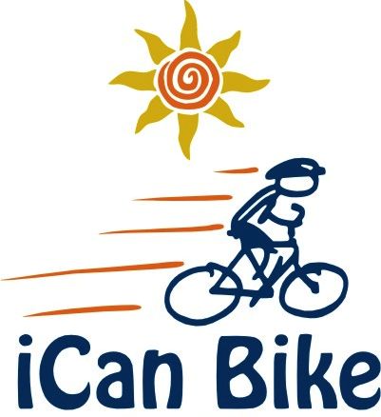

Volunteer Registration Form
Brookdale Community College Recreation and Events Center
765 Newman Springs Road
Lincroft, NJ 07738
August 14-18, 2017

We are pleased to offer this bike program to people with disabilities and look forward to having you play an important part in helping our special riders learn to ride a two-wheel bicycle independently

***NO PRIOR EXPERIENCE WITH PEOPLE WITH DISABILITIES NECESSARY***
AGE REQUIREMENT: Volunteers must be at least 16 years old

Volunteer Information:
Name:
Gender (M or F):
Age:
T-Shirt Size:
E-Mail:
Cell Phone:
Home Address:
Emergency Contact Name:
Emergency Contact Phone:

Comments:
Volunteer Orientation:

Please plan to attend our 45-minute orientation on Sunday August 13th at 4:00pm at Brookdale Community College. During this orientation, you will learn about how the iCan Bike program operates, what to expect each day in your role as a volunteer spotter and you will receive training tips on spotting your assigned rider. There will also be an opportunity to ask questions and meet other volunteers in your session. Also, please plan to arrive each day of camp 15 minutes prior to your session start time for a daily strategy/briefing session.

Volunteer Role:

Spotter: Walk/jog/run alongside a rider as they are learning to ride a bike during a 75-minute session (with short breaks) for 5 days Monday through Friday. You will provide encouragement and physical support, as needed.

Please place an “X” in the box below indicating your highest level of fitness:

I can jog at a moderate pace for one hour with short breaks

I can walk fast for one hour with short breaks

I can walk steadily for one hour with short breaks

I cannot walk steadily for one hour with short breaks

Comments (e.g. physical limitations, prior experience with children with disabilities, etc):

Session(s) Volunteering For:

NOTE: Volunteer spotters will walk/jog approximately 3 miles during EACH 75-minute session so please keep this in mind if volunteering for multiple sessions.

We ask volunteers to commit to attending all 5 days of camp for the session(s) you select. Riders bond with their assigned volunteers and rely on the same person to be there to support them each day of camp.

Please place an “X” in the box(es) indicating the 75-minute session(s) for which you would like to volunteer :

Session #1: 8:30 am – 9:45 am
Session #2: 10:05 am – 11:20 am
Session #3: 11:40 am – 12:55 pm
Session #4: 2:00 pm – 3:15 pm
Session #5: 3:35 pm – 4:50 pm
I’m available to help spot a rider still in need of support during the day(s) immediately following camp.
I’m available to help pack-up/move the bike equipment after the last session of the last day of camp.
Comments (e.g. day you cannot attend or will be arriving late):

Volunteer Liability Release

Volunteer Name:

By signing, I hereby expressly acknowledge that biking, like many sports such as swimming, golf, soccer, and gymnastics involves movement and physical activity, and that injury or mishap are possibilities in spite of all reasonable safeguards and precautions taken. Further, I hereby expressly acknowledge that photographs and/or videos of me may be taken by parties outside the control of iCan Shine in connection with participating in this program. I acknowledge that iCan Shine has limited or no control over such activities of third parties and has no control over any editing and/or use of such photos and/or video footage. I accept such risks as reasonable and proper, and agree to hold harmless the officers, principals, staff and volunteers of Brookdale Community College, iCan Shine, Inc., and Rainbow Trainers, Inc. should injury or mishap occur in this regard.

I give permission to be photographed and/or videotaped in print or electronic media by iCan Shine or third parties acting on behalf of iCan Shine. I acknowledge and agree that photographs and videos may be edited and used in whole or in part as desired for the purpose, which may be produced, duplicated, distributed and used for informational, promotional or other public purposes. I understand that photographs and video are not my property and there will be no compensation to me.

Volunteer Signature (typed signature is acceptable):

Submission Instructions:
Please e-mail this completed Volunteer Registration Form, including above Liability release to:
Babettez2u@gmail.com
Or mail to: Babette Zschiegner
3212 Allaire Road
Wall, NJ 07719

