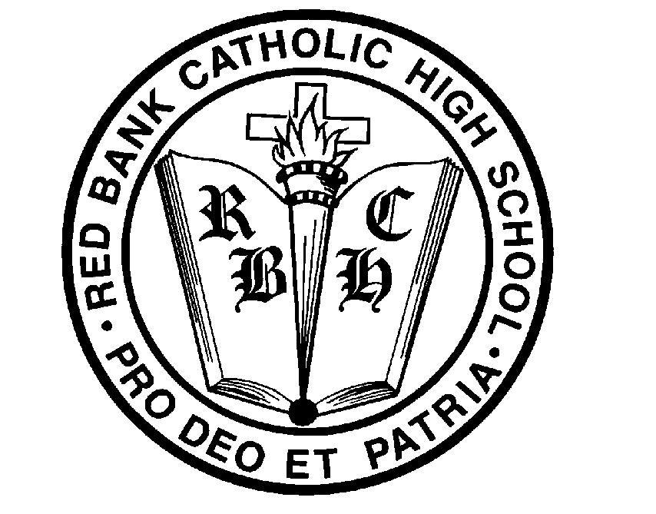
Red Bank Catholic High School
Summer Reading List 2017-2018

Our objective in assigning our students summer reading includes the following: to provide them with meaningful, relevant selections that will help foster their critical reading and analytical skills and hopefully spark a new curiosity and appreciation for literature, as well as the wondrous world around them.
We provide a variety of assessments, including projects, writing assignments, and objective quizzes. (English teachers will provide specific instructions and dates within the first two weeks of school.) These assessments enable our students to demonstrate their comprehension of the books they read, as well as their ability to analyze and connect with the literature.

FRESHMEN
Honors English I

Required Books: 7 Habits for Highly Effective Teens – Sean Covey (for Leadership class) Shakespeare: His Work and His World – Michael Rosen
The Rent Collector – Camron Wright

Choose 1 of the Following: We Were Liars – E. Lockhart
Station Eleven – Emily St. John Mandel
Mr. Penumbra’s 24-Hour Bookstore – Robin Sloan

Accelerated College Prep English I

Required Books: 7 Habits for Highly Effective Teens – Sean Covey (for Leadership class)
Fahrenheit 451 – Ray Bradbury

Choose 1 of the Following: Salt to the Sea – Ruta Sepetys
Believe: The Victorious Story of Eric LeGrand – Eric LeGrand, Mike Yorkey

College Prep English I

Required Books: 7 Habits for Highly Effective Teens – Sean Covey (for Leadership class)
The Lightning Thief – Rick Riordan

SOPHOMORES
Honors American Literature
Required Books: O Pioneers! – Willa Cather
The Winter of Our Discontent – John Steinbeck

Choose 1 of the Following: The Physick Book of Deliverance Dane – Katherine Howe
Into the Wild – John Krakauer
An Invisible Thread – Laura Schroff
The Immortal Life of Henrietta Lacks – Rebecca Skloot

ACP American Literature
Required Books: Hotel on the Corner of Bitter and Sweet – Jamie Ford
The Boys in the Boat – Daniel James Brown
Choose 1 of the Following: Bad – Jean Ferris
Gym Candy – Carl Deuker

CP American Literature
Required Book: Hatchet – Gary Paulsen

Choose 1 of the Following: The Glass Castle – Jeannette Walls
Into the Wild – Jon Krakauer

JUNIORS
All juniors are required to read the following book for their Religion class:
Left to Tell: Discovering God amidst the Rwandan Holocaust – Immaculee Ilibagiza

Honors British Literature
Required Books: Victory – Joseph Conrad
A Tale of Two Cities – Charles Dickens

ACP British Literature

Required Books: Jane Eyre – Charlotte Brontë
1984 – George Orwell

CP British Literature

Required Book: 5 Little Pigs – Agatha Christie

Choose 1 of the Following: The Jungle Books (Barnes & Noble Classics Series) – Rudyard Kipling
Storm Breaker – Anthony Horowitz

SENIORS
AP English Required Books:
A Passage to India – E. M. Forster
Gulliver’s Travels – Jonathan Swift
The Tempest – William Shakespeare

Honors World Literature Required Books:
Siddhartha – Herman Hesse
The Alchemist – Paulo Coelho
Things Fall Apart – Chinua Achebe

Literature/Media Studies Required Books:
In an Instant: A Family’s Journey of Love and Healing – Lee Woodruff
On Writing: A Memoir of the Craft – Stephen King

Detective Fiction Required Books:
On Writing: A Memoir of the Craft – Stephen King
The Murder of Roger Ackroyd – Agatha Christie
The Maltese Falcon – Dashiell Hammett

